EVERYTHING YOU NEED TO KNOW ABOUT
Reruns Are Fun Consignment Sale

WHAT IS CONSIGNING?
If you have consigned before, feel free to skip this section. Twice a year, we set up and organize an event for consignors (you). When you consign with us, you keep 70% of your sales commission. When we mail the check, we subtract a consignor fee of $15 unless you qualify for a volunteer perk that waives that fee. Please check the volunteer perks on our site for qualifying shifts. About three weeks after the sale, consignors are paid via check. You can waive the fee and increase your commission by volunteering. Please visit the site for additional details on volunteer perks at rerunsarefunsale.com/work.

SCHEDULE SUMMARY
If you are reading this document, then registration is open. Register today to save your spot! For the most accurate and up-to-date schedule visit rerunsarefunsale.com/consign. In order to complete the registration process you must select a drop off time. This is part of the process. Please select a time that works with you. If needed, you may change your drop off time at any time using our system up until drop off day.

REGISTER IN THE SOFTWARE
You are registered when you have a drop-off appointment.
● Understand the consignor agreement: Consignors keep 70% of their total sales unless you qualify for additional commission by volunteering.

o Go to www.rerunsarefunsale.com. Click on “Login” at the top of any page. If you are registering for the first time click “Join” at the top left hand corner.

● You should now be at our software login page, which should have the name of the sale and the full schedule. Next, click on “Join” on the left. A four-digit number will be assigned to you as your consignor ID/number when registering. This will be your username to login and your consignor ID on your printed tags. Contact us if you want to change your consignor number.

● If you are on an Apple computer and receive an error, try Firefox or Chrome.

● To complete registration, select a drop-off appointment.

GATHER THE ITEMS YOU WANT TO SELL
● Here are the clothing items we accept for Spring & Summer: shorts, sandals, swimsuits, summer pajamas, summer dresses, tank tops, adult summer clothing, summer maternity, or any other clothing meant for warmer weather.

● Here are the clothing items we accept for Fall & Winter Sales: sweaters, snow suits, coats, jackets, pants, winter pajamas, adult winter clothing, winter maternity, or any other clothing meant for the colder weather.

● Miscellaneous items we accept at all sales: t-shirts year-round, costumes, toys in working condition with batteries, purses, diaper bags, adult and maternity clothing, large items like bouncers and high chairs, car-seats, swings, strollers, bicycles, sporting goods,
electronics in working order with batteries, shoes and boots, books, DVDs and games, puzzles, and board games. All electrical items (whether plugin or battery) must be in good working order.

● We will not accept any items with stains, rips, tears, holes, missing buttons, a foul smell, or outdated. Items will be inspected at drop-off.
Please review the detailed list of what we accept. Everything must be in good condition or better, without missing or broken parts.

● All clothing must be cleaned and odor-free.

● All clothing must be current or trendy in style.

● We accept all sizes for both genders, from infant to adult.

● Onesies, socks, and tights will only be accepted if attached to a coordinating outfit or in a group of 3 or more.

● Maternity clothing or outfits in like-new condition

● Target clothing brands are accepted if in excellent condition.

● Shoes of all sizes.

● Cribs (please see recall website for cribs, link listed below), beds, changing tables, bookshelves, toy bins, small tables, chairs, and anything else related to children.

● Car seats that are 4 years old or younger, no accidents, and you are the original owner.

● Bikes, athletic equipment, riding toys, playhouses.

● Toys- All parts must be in a zip-loc bag and stapled/tied shut. Use only
packaging or duct tape. Toys must be in working order with batteries if needed.

● All stuffed animals must be battery-operated.

● Books, movies (no VHS), games, puzzles, computer-related items, and electronics.

● Playpens, high chairs, strollers, bouncy seats, swings, etc.

Check the CPSC Recalls webpage and/or We Make It Safer Simply Check to ensure none of the products you are selling have been recalled.
Please review the list of items that we do not accept.
● We no longer accept tags from other sales.
o We are still accepting tagged items from previous Reruns sales.
● Imagination Library, also known as Dolly Parton books.
● We will NOT accept clothing from discount stores such as Wal-Mart or Costco (i.e., George, McKids, Faded Glory, No Boundaries, NOBO, Kid Connection, etc.)
● Drop-side cribs and cribs made before Sept 5, 2011.
● Stand-alone mattresses without a crib/bed.
● Baby bath seats made before December 6, 2010
● Children's upper outerwear with drawstrings at the neck & hood in sizes 2T-12.

Also, children's upper outerwear clothing in sizes 2T-16 cannot contain drawstrings at the waist or bottom that are longer than 3 inches.
● Children's metal jewelry (CPSC lead safety requirements)
● Strong & rare earth magnet toys
● Growing toys that resemble jelly candy (i.e., polymer water balls).
● Stuffed animals and pillows
● Any item with a violent theme or inappropriate for children
● House slippers/shoes, broken items, and items in poor condition.

HANG/PREPARE YOUR ITEMS

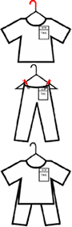
Clothes must be hung on WIRE HANGERS with hook facing to the left.

Only clothes 24 months and smaller may be on plastic hangers.

No straight pins or tiny safety pins (they easily become unclasped).
Clothing sets must be safety-pinned together on one hanger.
Pants/skirts/shorts must be safety-pinned on a hanger. Attach safety
pins on the top portion of the hanger (near the hook). Attach with pins
relatively close together and waistband tight. This prevents them from sliding down around to one side of the hanger and makes them easier to see when selling. This is especially important for adult clothing and
larger sizes.

SHOES must be fastened together with a zip tie or rubber band. No
shoes in bags allowed at all (we do not have the space for this). You may
leave the shoes in the original box if you have it.

PRICING YOUR ITEMS
Our happiest consignors are the ones who price competitively. It is better to price your items to sell at full price. Overpricing items in hopes that they will at least sell on half-price day rarely works. If the item is overpriced during the regular sale, then it will also be viewed by customers as overpriced during the half-price sale.

We recommend pricing items at 1/3 of the retail price if they are in excellent condition, and at 1/4 original price if in good condition. Price them to sell! Here are some pricing possibilities.

Bargain Brands (Retails $1-15): Carters, Oshkosh, Old Navy, Target Brands, and Children's Place. Better Brands (Retails $10-30): Gap, Polo, Justice, Gymboree
Boutique Brands (Retails $25+): Janie & Jack, Matilda Jane, Smocked Dresses, and Smocked Rompers

Here are some ideas to help your items sell.
● If the item still has tags on it and is brand new, it might sell at 25%-50% off the tagged price.
● Onesies need to be sold in sets or groups or as part of an outfit.
● Outfits sell better than items sold separately.
● Similar items sell better as sets, such as putting three leggings together.

TAG YOUR ITEMS
You can enter from a phone, tablet, or computer. Most people prefer a computer so that they can easily type in good descriptions.

● Login to our software.

● Click on “Consignor” on the left side, the link is directly below “Drop Off/Pick Up”

● Inside the “Consignor” tab, click on “Add Items”

● Here you will enter the description, gender, size, type (category of item), price in whole dollar increments. If you check the red “Dis” box, then the item will be marked half-price at the end of the sale. If you check the “D” box, then your item will be donated at the end of the sale.

o Please enter a detailed description in case the tag falls off the item. This does
happen, and a detailed description helps our volunteers locate the item and
reapply the tag. For example, instead of “book”, put in the title of the book.
Instead of “dress”, put in the brand and color/pattern.

● You can enter up to 10 items at a time. After that click on the green button which says, “Add Items” and these items will be saved. If you want to double-check what you just entered (which is a good idea if you are new to the system), then go to the Consignor tab on the left and click on “List Items”. Here you will see every item you have successfully entered.

● Most people enter all of their items into our software before moving on to printing. Printing Tags (called Cards in the software)

● All tags must be printed on white cardstock. Tags printed on paper will be rejected.
● We recommend using Firefox when printing cards. Other browsers can cause problems.

● Log in to our software, go to the Consignor tab, and then click on “print cards”.
● You can choose to print all cards or just print the ones that have not been printed.

● We recommend if you know how to make a pdf and print from the pdf.
If you need help, we can make the pdf for you and email it to you. Please try Firefox before asking us to email the pdf.

APPLYING THE TAG

For clothing, attach the tag vertically on right shoulder (when facing the garment) with a SAFETY PIN. NO straight pins or tiny safety pins. Amazon has good prices on safety pins. If you are using a tagging gun, then please place the barb in a seam or in the inside tag of the garment.

Also, use two barbs, as tags secured with guns can pull off easily. This photo shows how easy it is to put a hole in the shirt.

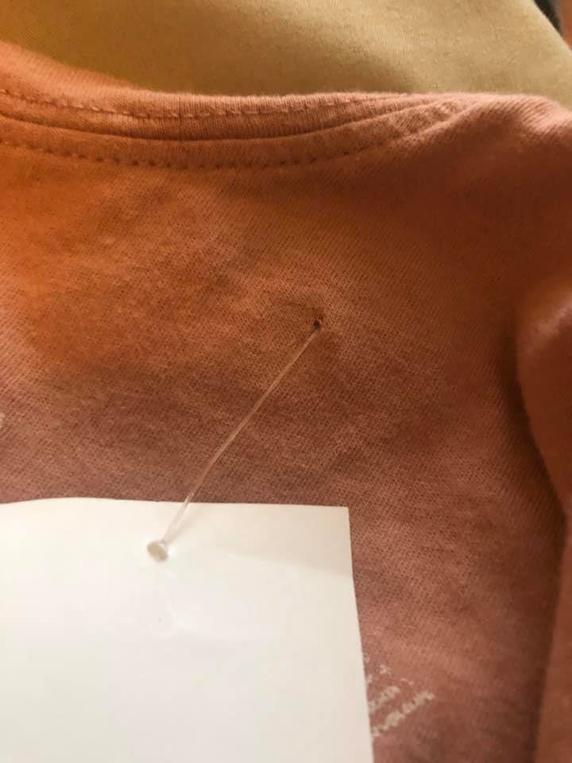

Large Items

Do NOT attach the tag to the item. Bring item & tag to drop-off. When you arrive, go to the tagging table. Here you will get a claim ticket per large item.
Fill out the consignor ID, the item ID, and the price on the white portion.
Attach the tag to the pink perforated portion using a staple. Then attach the
large claim ticket to your item. You can use tape, rubber bands, or zip ties. We
supply everything needed.

Do not cover any of the printed text on the tag unless using see-through tape.
We need to see all of the information that has been printed on the tag.

Books & DVDs
We recommend using Plastic Wrap (or commonly known as Saran Wrap) to keep the tag in
place and prevent damaging the exterior. Another option is to use ribbon/string tied around
the outside and then hole punch the tag and tie it to the ribbon/string.

THE MORE YOU TELL, THE MORE YOU SELL
Instagram and Facebook are the best ways to reach more shoppers! We need your help. Please follow us on Instagram and like our Facebook page. Then, when you share and tag, you are helping yourself make more money. We are not allowed to ask for a tag and share on a Facebook post, so we need your help.
Every consignor shopping pass needs to be used. If you do not plan on shopping, that’s ok! Just plan ahead to give your consignor shopping pass to someone who uses it. This is a great way to help everyone and bring in the best shoppers.
Tell everyone you know about the event. Part of what makes our event great is the personal advertising by consignors. That’s why the saying is true, “the more you tell, the more you sell!”
Make sure to engage with our Facebook Page and Instagram account by sharing posts and inviting people to the event.

Also, make sure your friends and family know about our PreSale, open to the public. Tickets are only $5 at the door (cash and Paypal accepted)!

DROPPING OFF
● Bring clothes separated by gender first, then organized by size SMALLEST to LARGEST.

This will help you put your clothes out quickly after inspection.

● Please allow time for drop-off. You might want to consider getting your own collapsible wagon if you are in a hurry.

● When you arrive, please follow the parking signs.
● If you need a rolling rack, please come inside and get one. We have plenty!
● We have discontinued VIP. All consignors need to select a drop-off appointment and come during their own window.
● All of your items must be inside before you can check in.
● You will receive shopping passes during check-in.
● After all your items are inspected, you will put out your items on the floor. Help is available if needed.
● Leave a box/crate for non-clothing with your name and consignor ID written on the outside. You do not need to leave a box if you are donating everything or only have clothes. The box will be returned to you at pick-up with unsold items.

SHOPPING THE PRE-SALE
Cash and credit cards only. We add 3% to all credit and debit transactions to help cover the processing fees. You must have your consignor pre-sale pass (given at drop-off) to enter the sale. A picture of it will not be allowed. This is because the pre-sale pass can be given be given away, and we have a strict rule of one person per shopping pass. The master schedule for pre-sale shopping is on the website.
To enter the pre-sale, use the same entrance you used for drop-off.
You can use our IKEA shopping bags or rolling racks to help you have a great shopping experience.

We do not have DISCARD racks out during the pre-sale because we have limited help (everyone wants to shop). If you change your mind about an item, please put it where it belongs.

PICKING UP
● Double-check pick-up times on the website/
● Please check in at the main door before retrieving your items. We want to make sure you get all of your stuff.
● All items not picked up by 8 PM will be donated.
● We will close for pick-up at 8 PM. We are not able to accommodate any pick-up times later than 8 PM. If you need help, some consignors in our Facebook Group can help out. That’s the best place to ask for someone to help you get your items at pick-up.

YOUR MONEY
● Our new payment for all consignors is in a check form.
o All consignors will receive payment within three weeks.

Reruns are Fun, and/or K&K Consignment LLC is not responsible for lost, stolen, or broken items during the sale window. Tagged items are dropped off in good faith. There is no way of tracking each item brought to the sale and put on the floor. For this reason, we are not responsible for any missing items upon pickup. Sellers agree to these terms upon registering for the sale.

WANT MORE MONEY?
We couldn’t exist without helpers. Here are the
perks.
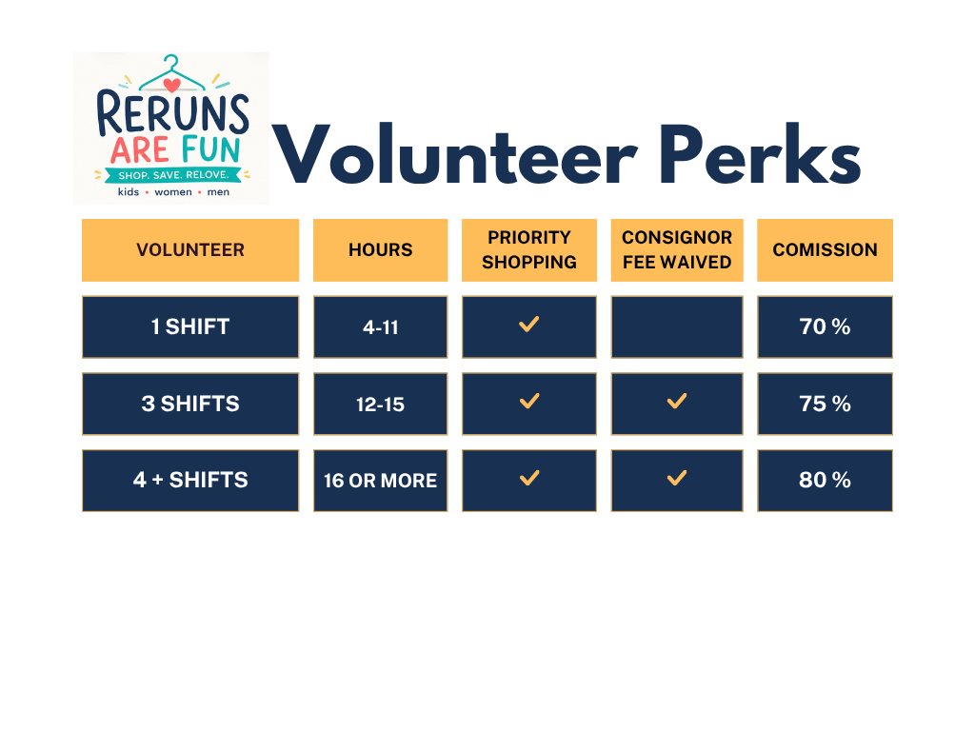CONTACT
● Email is the best and preferred: kelly@rerunsarefunsale.com

